Samuel J. Slabaugh
March 31, 1840 – February 2, 1904

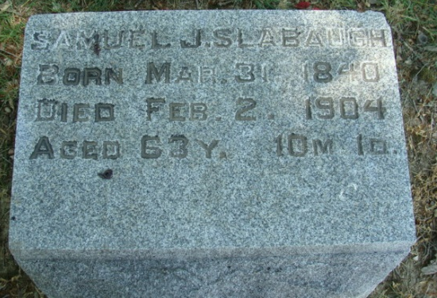
Photo by Alicia Kneuss

FROZE TO DEATH IN A CEMETERY

PORTLAND, Ind., Feb 8 – After digging a grave, and while waiting for a funeral procession to arrive, Samuel Slabaugh, sexton of the cemetery, froze to death and was found sitting bolt upright on a tombstone frozen stiff.

The Kingston-Whig Standard, Toronto, Ontario, Canada
February 8, 1904

**
Indiana, U.S., Death Certificates, 1899-2017
Name Samuel J Slaybaugh
Gender Male
Race White
Marital Status Married
Age 63
Birth Date 31 Mar 1840
Birth Place Fairfield Co., Ohio
Death Date 2 Feb 1904
Death Place Decatur, Adams, Indiana, USA
Death Registration Date 1904
Father Jacob Slaybaugh
Mother Elizabeth Brushman
Spouse Anna Elizabeth
Informant Caroline Zerkle; Decatur, Indiana
Burial February 5, 1904; Maplewood Cemetery

