Rebecca (York) Sizemore
June 18, 1969 – July 3, 2014

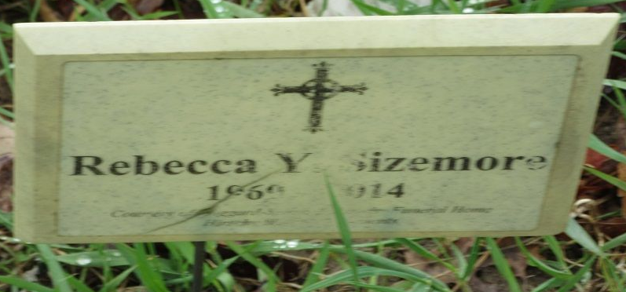
Photo by PLS

Rebecca Y. Sizemore, 44, of Decatur died at her residence on Thursday, July 3, 2014. Rebecca was born in Cincinnati, OH to Gary and Rebecca (Craig) York on June 18, 1969.
Surviving are her sons Chris Richmond and Anthony Sparks both of Decatur, IN and Billy Sparks of Westville, IN; a brother Gary York Jr of Kentucky; a sister Patricia Richmond of Cincinnati, OH and 5 grandchildren.
Funeral service will be held on Tuesday, July 8, 2014 at 11:00 a.m. at Haggard-Sefton & Hirschy Funeral Home with calling from 10:00-11:00 a.m. Pastor Dan York will be officiating. Burial will be in Decatur Cemetery.

Haggard & Sefton Funeral Home, Adams County, Indiana
July 4, 2014

**
Indiana, U.S., Death Certificates, 1899-2017
Name Rebecca Y Sizemore
Maiden Name York
Gender Female
Race White
Age 45
Birth Date 18 Jun 1969
Birth Place Cincinnati, Ohio
Death Date 3 Jul 2014
Death Place Decatur, Adams, Indiana, USA
Death Registration Date 2014
Father Gary York
Mother Rebecca Craig
Informant Chris Richmond; son; Decatur, Indiana
Burial Decatur Cemetery; Decatur, Indiana
Certificate Number 040989

**
Kentucky, U.S., Marriage Index, 1973-1999
Name Rebecca Y Richmond
Gender Female
Race White
Age 22
Estimated Birth Year 1969
Marriage Date 8 Jul 1991
Residence County after Married Kenton
State Kentucky
Spouse Anthony W Sparks
Spouse Age 25
Spouse Race White
Spouse Marital Status Never married
Volume Number 042
Certificate Number 20507
Marriage License County Campbell
Volume Year 1991

