Patricia J. (Noll) Sipe
August 25, 1928 – January 26, 2008

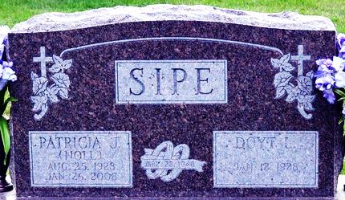
Photo by Deb Curry

Patricia J. Sipe, 79 years old of Willshire, Ohio, passed away at 2:30 p.m. on Saturday, January 26, 2008 in The Good Shepherd Hospice located in Auburndale, Florida.
Pat was born on Saturday, August 25, 1928 in Adams County, Indiana the daughter of the late Thompson R. Noll and the late Allie M. (Bender) Noll. She married Doyt L. Sipe on March 28, 1948 in Willshire, Ohio and he survives.
For the past several years Pat and Doyt enjoyed spending their winters in Florida, along with their many Florida friends.
She was a giving and loving wife, mother, and grandmother with a wonderful sense of humor who enjoyed attending her grandchildren's sporting events. In her leisure time she enjoyed playing bingo, cards and gardening.
Pat was a member of the Decatur Church of God in Decatur, Indiana. She was a past state officer with the Ohio Rural Letter Carriers Association and attended many state and national conventions. Pat served on the board of the Willshire Youth Activities; a 4-H Club Advisor; served on the Election Board as a poll worker; formerly taught Sunday School at the Willshire Church of God.
Pat retired from the United States Postal Service as a rural Convoy mail carrier, and prior to that, she served as a clerk in the Willshire Post Office, having a total of 24 years of service.
Surviving are her husband, Doyt L. Sipe of Willshire, Ohio; daughter, Mrs. Sandra K.(Dale)Schwartz of New Bremen, Ohio; daughter, Carolyn S. Archer of Decatur, Indiana; daughter, Mrs. Susan A.(Duane) Roehm of Willshire, Ohio; daughter-in-law, Mrs. Marcia (Dennis) Hoffhines of Rockford, Ohio; sister, Juanita M. Myers of Decatur, Indiana; brother, Franklin 'Tom' (Shirley) Noll of Decatur, Indiana; brother, Robert E. (Bonnie) Noll of Decatur, Indiana; sister-in-law, Mrs. Betty L. Moser of Berne, Indiana; eleven grandchildren; and thirteen great-grandchildren.
Preceding Patricia in death was one son, Ronald D. Sipe; two brothers, Richard B. Noll and Carl T. Noll; and two sisters, Eloise A. Noll and Mary M. Neireiter.
Funeral services will be held at 1:30 p.m. Friday, February 1, 2008 in the Decatur Church of God with Dr. Robert Brink and Pastor Sandy Hildebrand officiating. Interment will follow in the Decatur Cemetery, Decatur, Indiana. Friends will be received from 1-3 and 4-8 p.m. Thursday, January 31, 2008 in the Zwick and Jahn Funeral Home, Decatur, Indiana and one hour prior to the service at church on Friday.
Preferred memorials are to the Van Wert Heart Association; Family Hospice of N E Indiana -Berne; or the Decatur Church of God.

Zwick & Jahn Funeral Home, Adams County, Indiana
January 27, 2008

