Martha E. (Starkey) Sipe
December 25, 1888 – November 4, 1973

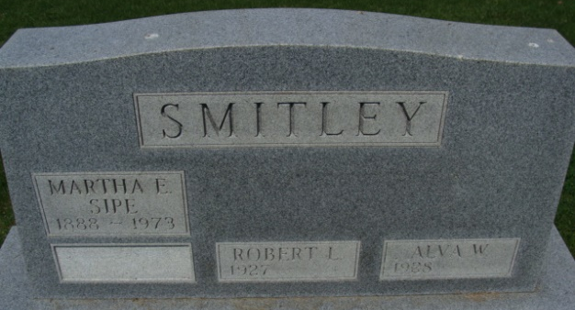
Photo by Alicia Kneuss

Martha E. Sipe, 84, Dies at Care Center
Mrs. Martha E. Sipe, 84, of 716 Line Street, widow of Harry Sipe, died at 1:05 p.m. Sunday at the Decatur Community Care Center, following an extended illness. She was a member of the First United Methodist Church.
Born in Clinton County on December 25, 1888, she was the daughter of Luther and Charlotte Reeder-Starkey, and was married to Harry Sipe. He preceded her in death in 1960.
Survivors include one daughter, Mrs. Clarence (Ruth) Smitley, of Decatur; three grandsons, Vernon E. Smitley, of Birmingham, Mich.; Robert L. Smitley, of Decatur and Alva W. Smitley, of Decatur; and five step-grandchildren. One grandson, Carl Smitley, and three sisters and nine brothers preceded her in death.
Funeral services will be held at 1:30 p.m. Wednesday at the Winteregg-Linn Funeral Home, with Rev. Harold Leininger officiating. Burial will be in the Decatur Cemetery. Friends may call at the funeral home after 2 p.m. Tuesday.

Decatur Daily Democrat, Adams County, Indiana
Monday, November 5, 1973

**
Indiana, U.S., Marriages, 1810-2001
Name Martha Clark
[Martha Starkey]
Gender Female
Race White
Age 58
Event Type Marriage Registration (Marriage)
Birth Date 25 Dec 1888
Birth Place Indiana
Marriage Date 20 Jun 1946
Marriage Place Indiana, United States
Residence Place Decatur, Indiana
Father Luther Starkey
Mother Charolett Reader
Spouse Harry Sipe
Page 248
FHL Film Number 002321635

