Doyt L. Sipe
January 12, 1928 – May 30, 2017

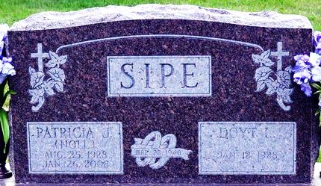
Photo by Deb Curry

Doyt L. Sipe, 89, passed away on Tuesday, May 30, 2017. He was a former longtime resident of Willshire, Ohio and had resided at Adams Woodcrest in Decatur for the past several months. He had wintered at Florida Camp Inn for over 15 years.
He was born on Thursday, January 12, 1928 in Adams County, Indiana the son of the late Earl E. Sipe and the late Alma L. (Raudenbush) Sipe. He married Patricia J. Noll on March 28, 1948 in Willshire, Ohio and she preceded him in death on January 26, 2008.
Doyt attended the Decatur Church of God; was a former member of the Willshire Lion's Club; and served as a board member of the Willshire Town Council. He was a Van Wert County Democrat Committeeman and was a state officer of the Ohio Rural Letter Carriers Auxiliary. Doyt was a cancer survivor. He was proud of attending his grand and great-grandkids sporting events. He was an avid Ohio State, University of Michigan, Cincinnati Reds, & New York Yankees fan.
He was a graduate of Pleasant Mills High School where he played varsity basketball. Doyt retired in 1983 from International Harvester with 29 years of service and in 1990 he retired from the Ohio Highway Patrol with four years of service. He also enjoyed farming with his father in Blue Creek Township.
Surviving are three daughters, Sandra (Dale) Schwartz of New Bremen, OH; Carolyn Archer of Decatur, IN; & Susan (Duane) Roehm of Willshire, OH; daughter-in-law, Marcia (Dennis) Hoffhines of Rockford, OH; 11 grandchildren, David (Laura) Schwartz; Christine Schwartz; Nichole (Eric) Hawkins; Denise (Jeremy) Rodeffer; Brandon (Alicia) Bates; Brenden (Marci) Bates; Gregory Roehm; Cameron (Melissa) Roehm; Ryan (Kelly) Sipe; Carey (Brook) Sipe; Scott (Mindy) Sipe; & 21 great-grandchildren.
Other than his wife, Patricia, he was preceded in death by a son, Ronald D. Sipe and a sister, Betty Moser.
Funeral services will be held at 1:00 p.m. Sunday, June 4, 2017 in the Zwick & Jahn Funeral Home in Decatur with Pastor Sandy Hildebrand and Rev. Dr. Robert Brink officiating. Interment will follow in the Decatur Cemetery. Friends will be received from 1 to 5 p.m., Saturday, June 3 in the Zwick & Jahn Funeral Home in Decatur and two hours prior to the service on Sunday at the funeral home.
Preferred memorials are to Willshire Youth Activities or Adams County Community Foundation-Heart Fund.

Zwick & Jahn Funeral Home, Adams County, Indiana
May 31, 2017

