Tamara K. (Baumgartner) Singleton
December 29, 1960 -

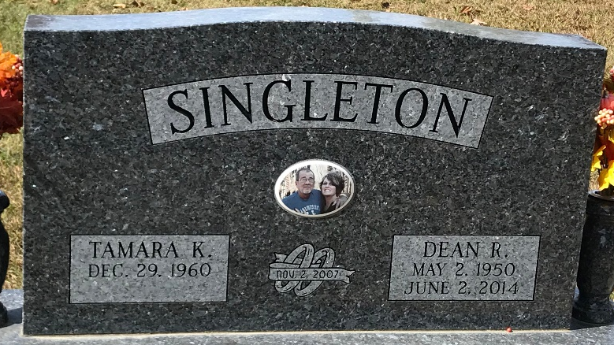
Photo of PLS

