Betty Jane (Miller) Singleton-Shady
January 4, 1929 – June 1, 1995

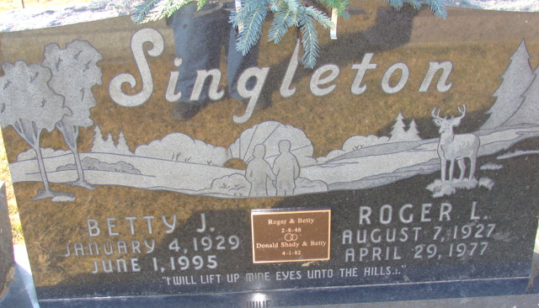
Photo by Alicia Kneuss

BETTY J. SHADY
Betty J. Shady, 66, rural Decatur, died unexpectedly of pulmonary embolism at 8:50 a.m. Thursday in her winter residence at Nokomis, Fla. She was born January 4, 1929 in Monroeville to Harry A. and Clara A. (Kelly) Miller. She was married to Roger L. Singleton, former Adams County Sheriff and Indiana State Representative, on February 8, 1948. He died April 29, 1977. She married Donald E. Shady on April 1, 1982. He survives.
Mrs. Shady retired in 1990 as a licensed practical nurse following 10 years of employment with Adams County Memorial Hospital. She was licenses in Indiana and Florida. Mrs. Shady was also a court reporter, a jail matron and secretary for the sheriff's department.
She was a member of the First United Methodist Church and the Indiana General Assembly Women's Association. She had been active in the Democratic Party and was a former secretary for the Adams County Democratic Women's Club. Mrs. Shady was also a Sunday School teacher and was active with the Red Cross.
Surviving, in addition to her husband, are six daughters, Mrs. David (Sandra) Collier, Oakwood Addition; Mrs. John (Susan) Fuelling, rural Decatur; Saran Winkler, Sarasota, Fla.; Mrs. Robert (Becky) Meyer, Colorado Springs, Colo.; Mrs. Craig (Kathy) Fiedor, rural Decatur; and Mrs. Chris (Melinda) Liby, rural Decatur; two sons, Jeff Shady, rural Decatur, and Scott Singleton, Decatur; four sisters, Pauline Fisher, Decatur; Mrs. Don (Mary) Koos, Decatur; Lena Andrews, New Haven; Mrs. William (Evelyn) Berron, Celina, Ohio; and 22 grandchildren. She was preceded in death by three brothers, Clarence, Edward and Gene Miller.
Funeral services are at 10:30 a.m. Monday in First United Methodist Church. Burial will follow in Decatur Cemetery. Visiting hours are 10 a.m. - 9 p.m. Sunday at Zwick-Sefton & Jahn Funeral Home and one hour prior to services at the church Monday.
Memorials are to the Adams County Heart Club or Adams County Chapter of the American Cancer Society.
Adams County (IN) Public Library
Obit book # 9
Handwritten: Saturday, June 3, 1995

