Roger L. Singleton
August 7, 1927 – April 29, 1977

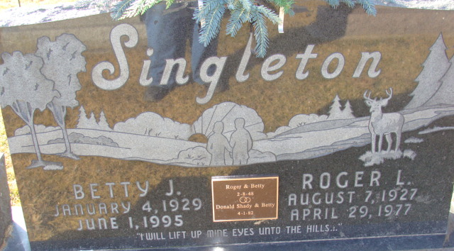
Photo by Alicia Kneuss

Roger L. Singleton
in the Indiana, U.S., Death Certificates, 1899-2017
Name Roger L. Singleton
Gender Male
Race White
Marital Status Married
Age 49
Birth Date 7 Aug 1927
Birth Place Indiana
Death Date 29 Apr 1977
Death Place Decatur, Adams, Indiana, USA
Death Registration Date 1977
Father Frank Singleton
Mother Helen Rayer
Spouse Betty Jane Miller
Informant Mrs. Roger Singleton; wife; Decatur, Indiana
Burial May 2, 1977; Decatur Cemetery; Decatur, Indiana

