Oleta J. (Garrett) Singleton
October 19, 1936 – February 15, 2005

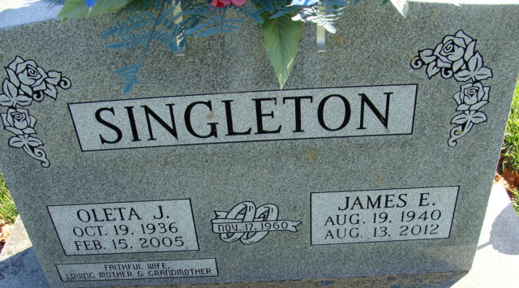
Photo by Alicia Kneuss

Oleta J. Singleton, 68, of Decatur, passed away Tuesday, Feb. 15, 2005.

News-Sentinel, Allen County, Indiana
Thursday, February 17, 2005

**
Oleta J Singleton
in the Indiana, U.S., Death Certificates, 1899-2017

Name Oleta J Singleton
[Oleta J Garrett]
Gender Female
Race White
Age 68
Marital Status Married
Birth Date 19 Oct 1936
Birth Place Witchita Falls, Texas
Death Date 15 Feb 2005
Death Place Decatur, Adams, Indiana, USA
Death Registration Date 2005
Father: Jim Garrett
Mother: Evalca Reiger
Spouse: Jim Singleton
Informant: Jim Singleton; husband; Decatur, Indiana
Burial: February 18, 2005; Decatur Cemetery; Decatur, Indiana

