Nettie S. (Mann) Singleton
May 8, 1880 – September 16, 1960

\ 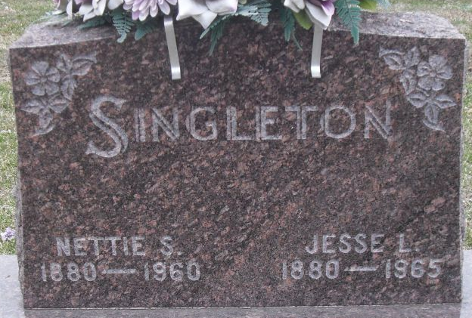
Photo by Alicia Kneuss

Nettie Singleton Dies Last Evening
Mrs. Nettie Singleton, 80, wife of Jesse L. Singleton and lifelong resident of Root Township, died at 8 o’clock Friday evening at her home, five miles northwest of Decatur. She had been bedfast for the past two years.
She was born in Root Township May 8, 1880, a daughter of Joseph E. and Louise C. Kiess-Mann, and was married to Jesse L. Singleton Oct. 8, 1903. Mrs. Singleton was a member of the Mt. Pleasant Methodist Church her entire life, and was also a member of the Root Township Home Economics Club.
Surviving in addition to her husband are three sons, Franklin J. and Everett C. Singleton, both of Root Township, and Kenneth N. Singleton of Decatur; seven grandchildren; seven great-grandchildren; one brother, Dr. Frank C. Mann of Rochester, Minn., and three sisters, Mrs. Ethel Grandstaff of Root Township, Mrs. Lulu Vance of Fort Wayne, and Mrs. George Sprague of Decatur. Three brothers and one sister preceded her in death.
Funeral services will be conducted at 1:30 p.m. Monday at the Zwick Funeral Home and at 2 p.m. at the Mt. Pleasant Methodist Church. The Rev. E.J. Arthur and the Rev. George Christian will officiate, and burial will be in the Decatur Cemetery. Friends may call at the funeral home after 7 p.m. today until time of the services.

Adam County Historical Museum, Adams County, Indiana
January 1958 – December 1960 Scrapbook
Handwritten date: Saturday, September 17, 1960

**
Indiana, U.S., Death Certificates, 1899-2017

Name Nettie Singleton
[Nettie Mann]
Gender Female
Race White
Marital Status Married
Age 80
Birth Date 8 May 1880
Birth Place Indiana
Death Date 16 Sep 1960
Death Place Geneva, Adams, Indiana, USA
Death Registration Date 1960
Father Joseph E Mann
Mother Louise C Kiess
Informant Jesse L Singleton; husband; Decatur, Indiana
Burial September 19, 1960; Decatur Cemetery; Decatur, Indiana

