Mary Letitia Singleton
May 15, 1888 – February 28, 1955

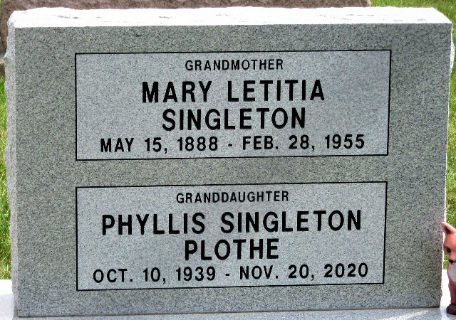
Photo by PLS

Mary L. Singleton Is Suicide Victim.
Funeral services Thursday afternoon. Mary Letitia Singleton, 66-year-old native of Adams County, and a resident of Monroe, Route 1, near the old Riniger schoolhouse, drowned herself in the school cistern Monday afternoon at about 2 p.m. The woman, who had been in poor health for the past year and was failing mentally, talked to her daughter-in-law at 1:30p.m. and gave no indication of intention to commit suicide. She was found in the cistern at 4:30 p.m. by George Strickler, who, with members of her family and others, had been searching for her about an hour
It was the second suicide within a week and a half in Adams County. John A. Stuckey took his life February 20 by hanging himself at his farm home in Hartford Township.
Sheriff Merle Affolder, Deputy Charles Arnold and coroner Harmon Gillig were called when the body was discovered. Coroner Gillig stated that she had been dead for a couple of hours.
Born in Adams County, March 15, 1888 to William and Abagail Warner-Singleton, she was a lifelong resident of the county and a member of the Church of God.
Surviving is her son Luther Singleton of Monroe, Route 1, two brothers, Jesse Singleton of Decatur and John Singleton of Albion, and four grandchildren. One brother is deceased.
The body has been taken to the Gillig & Doan Funeral Home in Decatur, where friends may call after 7o'clock this evening. Funeral services will be conducted Thursday at 2:30 p.m. at the funeral home with the Rev. W.H. Kirkpatrick officiating. Burial will be in the Decatur Cemetery.

Decatur Daily Democrat, Adams County, Indiana
Tuesday, March 1, 1955

