Luther Jay Singleton
September 27, 1913 – September 13, 1966

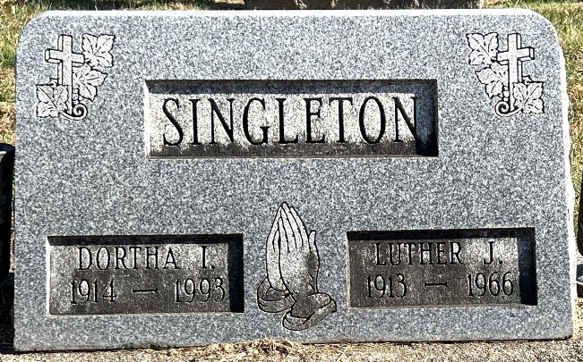
Photo by Deb Curry

Luther Singleton Dies Unexpectedly
Luther J. Singleton, 52, an employe of the Central Soya Co. in this city for many years, died at 1:30 p.m. Tuesday at the Adams county memorial hospital, shortly after suffering a heart attack at his home one mile south of Monroe.
Born in Root township Sept. 27, 1913, he was a son of Mrs. Mary Letitia Singleton. He graduated from Decatur high school in 1934 and was married to Dortha Strickler Dec. 25, 1936.
Mr. Singleton had been employed in the M. & R. Department at Central Soya since 1939. He was a member of the Church of God.
Surviving are his wife; one son, Gordon Singleton of Fort Wayne; three daughters, Miss Phyllis Singleton, at home, and Mrs. Kenneth (Kay) Martin and Mrs. Lynford (Annie) Weiland, both of Monroe route 1; and four grandchildren.
Funeral services will be conducted at 1:30 p.m. Friday at the Zwick funeral home, with Rev. Huston Bever, Jr., officiating. Burial will be in the Decatur cemetery. Friends may call at the funeral home after 7 p.m. today until time of the services. His body was interred on September 16, 1966 in Decatur, Adams County, Indiana, Decatur Cemetery.
Preferred memorials are to the Church of God building fund or to the heart fund.

Decatur Daily Democrat, Adams County, Indiana
Wednesday, September 14, 1966

**
Indiana, U.S., Birth Certificates, 1907-1944
Name Luther J McQuay; not legitimate
Gender Male
Birth Date 27 Sep 1913
Birth Place Root, Adams, Indiana, USA
Father William McQuay; age 40
Mother Mary Letitia Singteton; age 25; 1st child
Certificate Number 408
Roll number 40474_357396
Volume Range 599 – 603
**

Indiana, U.S., Death Certificates, 1899-2017
Name Luther Jay Singleton
Gender Male
Race Caucasian (White)
Marital Status Married
Age 52
Birth Date 27 Sep 1913
Birth Place Indiana
Death Date 13 Sep 1966
Death Place Decatur, Adams, Indiana, USA
Death Registration Date 1966
Parents Not listed
Informant Dortha Singleton; wife; Monroe, Indiana
Burial September 16, 1966; Decatur Cemetery; Decatur, Indiana

