Dortha I. (Strickler) Singleton-Lengerich
July 19, 1914 – August 17, 1993

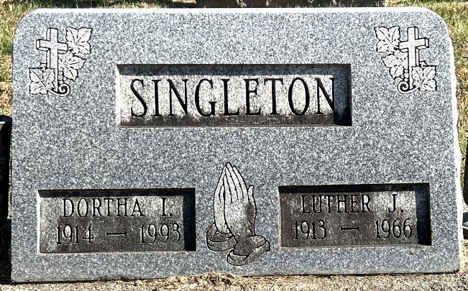
Photo by Deb Curry
Dortha I. Lengerich, 79, a rural Monroe resident for 54 years, died Tuesday in Lutheran Hospital, Fort Wayne, after an illness of 2 1/2 weeks. She was born on July 19, 1914 in Decatur and married Luther J. Singleton on December 25, 1936; he died September 13, 1966. She married Herbert J. Lengerich on July 19, 1973; he died February 19, 1989.
She was a homemaker who worked in Adams Central School's cafeteria from 1968-74, a lifelong member of Decatur Church of God, and active in the Seniors Forget-Me-Nots organization.
Surviving are three daughters, Mrs. Fred (Phyllis) Plothe, rural Decatur; Mrs. Dennis (Kay) Hartnett, Weiser, Idaho; and Mrs. Lynford (Annie) Weiland, rural Monroe; a brother, Roy E. Strickler, Decatur; nine grandchildren; and 14 great-grandchildren. A son, Gordon L. Singleton, died on March 30, 1988.
Funeral services will be at 4 p.m. Saturday in Decatur Church of God, Pastor Sandy Hildebrand officiating. Burial will be in Decatur Cemetery with Grant Singleton, Grady Singleton, Ted Plothe, Lyndsey Weiland, Lyne Killen, Tish Plothe, Kem Haines, and Gywn Beck as pallbearers. Visiting hours are from 2-9 p.m. Friday in Zwick-Sefton and Jahn Funeral Home, Decatur, and 2-4 p.m. Saturday in the church.
Preferred memorials are to the church's memorial fund.

Decatur Public Library, Adams County, Indiana
Obit files
handprinted date of Thursday, August 19, 1993
**
Indiana, U.S., Death Certificates, 1899-2017
Name Dortha I Lengerich
[Dortha I Strickler]
Gender Female
Race White
Marital Status Widowed
Age 79
Birth Date 19 Jul 1914
Birth Place Decatur, in Adams
Death Date 17 Aug 1993
Death Place Fort Wayne, Allen, Indiana, USA
Death Registration Date 1993
Father George Strickler
Mother Ruby Harvey
Informant Phyllis Plothe; daughter; Decatur, Indiana
Burial August 21, 1993; Decatur Cemetery; Decatur, Indiana

