Kenneth Norval Singleton
May 24, 1909 – September 2, 1988

\ 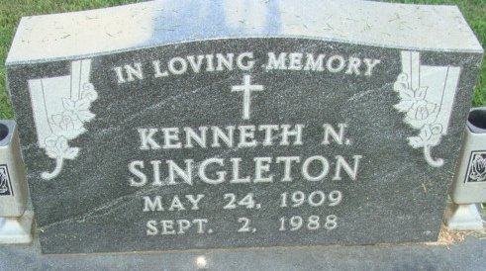 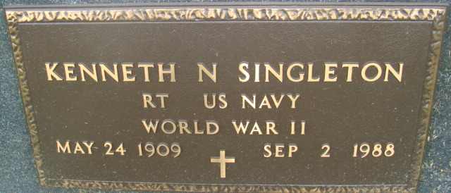
Photo by Alicia Kneuss

Kenneth Norval Singleton
in the Indiana, U.S., Death Certificates, 1899-2017
Name Kenneth Norval Singleton
Gender Male
Race White
Marital Status Married
Age 79
Birth Date 24 May 1909
Birth Place Adams County, Indiana
Death Date 2 Sep 1988
Death Place Berne, Adams, Indiana, USA
Death Registration Date 1988
Father Jesse L Singleton
Mother Nettie S Mann
Spouse Elizabeth
Informant Mrs. Elizabeth Singleton; wife; Decatur, Indiana
Burial September 7, 1988; Decatur Cemetery; Decatur, Indiana

