Jesse L. Singleton
November 21, 1880 – January 6, 1965

\ 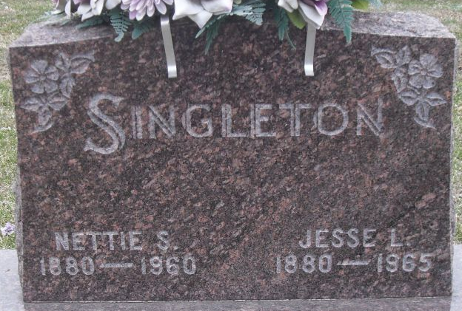
Photo by Alicia Kneuss

Jesse L Singleton
in the Indiana, U.S., Death Certificates, 1899-2017
Name Jesse L Singleton
Gender Male
Race Caucasian (White)
Marital Status Widowed
Age 84
Birth Date 21 Nov 1880
Birth Place Indiana
Death Date 6 Jan 1965
Death Place Decatur, Adams, Indiana, USA
Death Registration Date 1965
Father William Singleton
Mother Abigail Warner
Informant Everett C. Singleton; son; Decatur, Indiana
Burial January 9, 1965; Decatur Cemetery; Decatur, Indiana

