James E. Singleton
August 19, 1940 – August 13, 2012

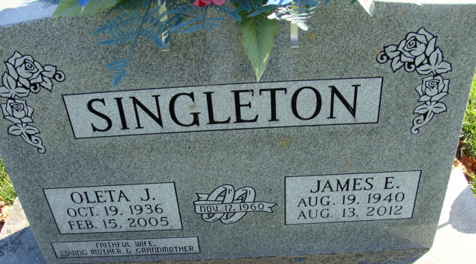
Photo by Alicia Kneuss

James Singleton, 71 years old of Decatur, Indiana, passed away at 11:10 p.m. on Monday, August 13, 2012 in the Van Wert Community Health Professionals Hospice located in Van Wert, Ohio.
James was born on Monday, August 19, 1940 in Decatur, Indiana the son of the late Everett Clark Singleton and the late Helen Marie (Hoover) Singleton. He married the late Oleta Garrett on November 17, 1960 in Texas and she passed away on February 15, 2005.
James was a member of the Pleasant Mills United Methodist Church; a former leader of Adams County 4-H Horse & Pony Club; and the Quarterhorse Association. James served his country in the United States Air Force during the Cuban Missile Crisis. James retired from the Dana Corp. in Fort Wayne, Indiana after 41 years of service.
Surviving are his daughter, Camilla (Kenneth) Brummette of Ohio City, OH; son, James Singleton Jr. of Decatur, IN; son, Christopher Singleton of Decatur, IN; son, James Wayne Garrett of Rush Springs, OK; son, Joseph Clay Garrett of Poulsbo, WA; brother, Dean (Tammy) Singleton of Decatur, IN; granddaughter, Cindy Brummette of Ohio City, OH; granddaughter, Patty Brummette of Ohio City, OH; grandson, Kenny (Sherry) Brummette Jr. of Convoy, OH; grandson, Alonzo Brummette of Ohio City, OH; and five great-grandchildren.
Preceding James in death was one brother Dave Singleton.
Funeral services will be held on Saturday, August 18, 2012 at 10:30 a.m. in the Zwick & Jahn Funeral Home with Pastor Michelle Isch officiating. Interment will follow in the Decatur Cemetery. Military Graveside Honors will be conducted by American Legion Post 43 Color Guard. Friends will be received on Friday, August 17, 2012 from 2 to 4 & 5 to 8 p.m. in the Zwick & Jahn Funeral Home, Decatur.
Preferred memorials are to Pleasant Mills United Methodist Church.

Zwick & Jahn Funeral Home, Adams County, Indiana
August 14, 2012

