Helen M. (Hoover) Singleton
September 30, 1916 – December 28, 2005

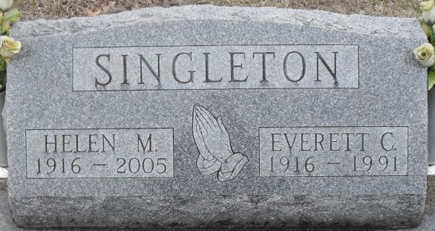
Photo by Stephen & Andrea Brangan

A native of Wells County, Helen M. Singleton, 89, of Decatur died at 1:05 p.m. Wednesday, Dec. 28, 2005, at Woodcrest Nursing Center, where she had resided the last two and one-half years.
Mrs. Singleton was a homemaker and also had been employed as a cook at Monmouth School.
She was a member of the Mt. Pleasant United Methodist Church for 61 years and the United Methodist Women. Most recently, she had attended Decatur Church of God.
Born Sept. 30, 1916, in Wells County to Robert D. and Cordelia J. (Shady) Hoover, her marriage on March 27, 1937, in Decatur was to Everett C. Singleton, who preceded her in death on July 22, 1991.
Survivors include three sons, James E. Singleton and Dean R. Singleton, both of Decatur, and David M. Singleton of Venice, Fla.; 11 grandchildren; 10 great-grandchildren; and two great-great-grandchildren.
She was preceded in death by three sisters, Leitha Fosnaugh, Lida Stahl and Ruby Hoover; and two brothers, including Neil Hoover.
Calling is from 2 to 5 and 6 to 8 p.m. Friday at Zwick & Jahn Funeral Home, Decatur. Services are at 10:30 a.m. Saturday at the funeral home with Pastor Sandy Hildebrand officiating. Burial will be in Decatur Cemetery.
Preferred memorials are to the donor's choice.

Bluffton News-Banner, Wells County, Indiana
Thursday, December 29, 2005

