Helen L. (Rayer) Singleton
June 2, 1907 – March 21, 1975

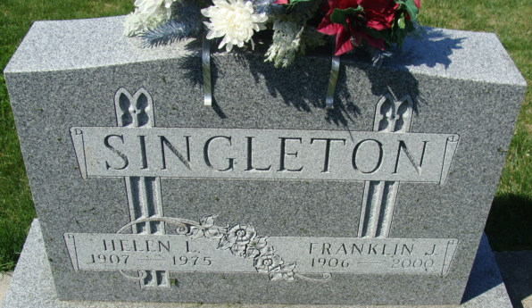
Photo by Alicia Kneuss

Helen L. Singleton, 67, of route 2, wife of Frank Singleton, died at 2:15 p.m. Friday shortly after she was admitted to Caylor-Nickel Clinic in Bluffton. Death was attributed to a heart attack.
She was a member of the Mount Pleasant United Methodist Church for almost 50 years and a member of the WSCS of the church.
Born in Ohio City, O., on June 2, 1907, she was a daughter of David and Loretta Bonnell-Rayer and was married to Frank Singleton on Feb. 27, 1926. Her husband was a former highway department supervisor for both Adams County and the state.
Survivors include her husband; two sons, Kenneth of Decatur and Roger of route 1, who was a former Adams County Sheriff and a former state representative from Adams and Wells Counties; one daughter, Mrs. Edward (Kathryn) Ritter of Decatur; 11 grandchildren and three great-grandchildren. Two brothers and two sisters preceded her in death.
Funeral services will be held at 10:30 a.m. Monday at Zwick Funeral Home, with Rev. Noel Reed and Rev. Fuhrman Miller officiating. Burial will be in the Decatur Cemetery. Friends may call after 10 a.m. Sunday.
Preferred memorials are to the Diabetes Foundation or the Heart Fund.

Decatur Daily Democrat, Adams County, Indiana
Saturday, March 22, 1975

