Franklin J. Singleton
February 28, 1906 – August 18, 2000

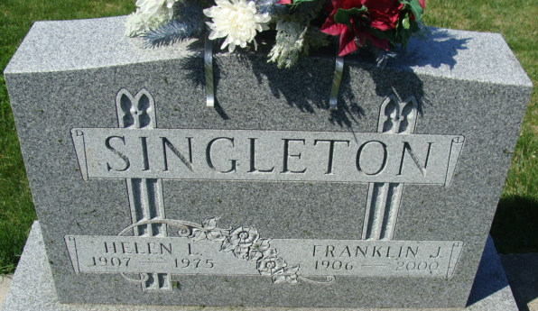
Photo by Alicia Kneuss

Franklin J. Singleton
Former Adams County Highway Superintendent

Franklin J. Singleton, 94, 1300 Mercer Ave., died at 12:50 p.m. Friday in Woodcrest Nursing Home. He was born February 28, 1906, in Root Township, the son of Jessie L. and Nettie Mann Singleton. He married Helen L. Rayer on February 27, 1926; she died on March 21, 1975.
Mr. Singleton headed Adams County's Highway Department from 1951-55; was an employee of the Indiana Highway Department for 10 years; was a former employee of Meshberger Brothers Stone Quarry; and retired from Northwest Schools in 1971. He also served as a precinct committeeman for several years.
Survivors include a daughter, Mrs. James (Kathryn N.) Ritter, rural Decatur; a son, Kenneth P. Singleton, Decatur; 11 grandchildren; 23 great-grandchildren; and one great-greatgrandchild.
He was preceded in death by a son, Roger; and two brothers, Kenneth N. and Everett Singleton.
Funeral services will be at 1 p.m. Monday in Zwick & Jahn Funeral Home, Rev. Fuhrman Miller officiating. Burial will be in Decatur Cemetery. Visiting hours are 11 a.m.-2 p.m. and 4-6 p.m. Sunday.
Preferred memorials are to Worship for Shut-Ins and Riley Children's Hospital.

Decatur Daily Democrat, Adams County, Indiana
Saturday, August 19, 2000

