Everett C. Singleton
March 2, 1916 – July 22, 1991

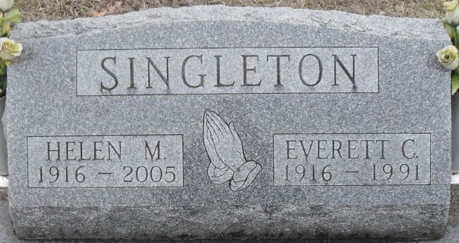
Photo by Stephen & Andrea Brangan

Everett C Singleton
in the Indiana, U.S., Death Certificates, 1899-2017
Name Everett C Singleton
Gender Male
Race White
Marital Status Married
Age 75
Birth Date 2 Mar 1916
Birth Place Adams County, Indiana
Death Date 22 Jul 1991
Death Place Fort Wayne, Allen, Indiana, USA
Death Registration Date 1991
Father Jesse L Singleton
Mother Nettie S Mann
Spouse Helen M Hoover
Informant Helen Singleton; wife; Decatur, Indiana
Burial July 26, 1991; Decatur Cemetery; Decatur, Indiana

