Dean R. Singleton
May 2, 1950 – June 2, 2014

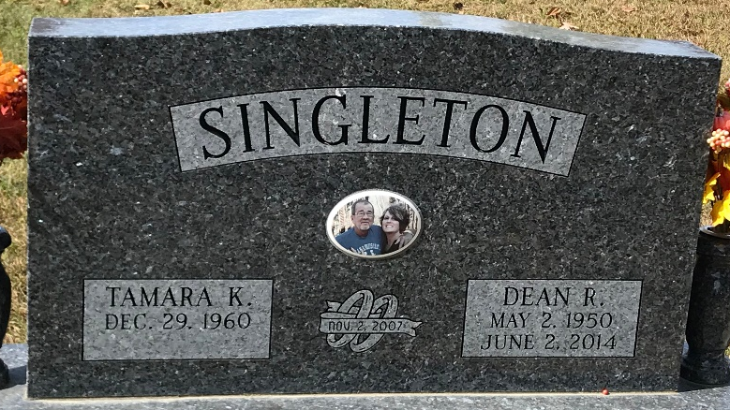
Photo of PLS

Dean R. Singleton, 64 years old of Decatur, Indiana, passed away at 9:15 a.m. on Monday, June 2, 2014, in the Adams Memorial Hospital located in Decatur. Dean was born on Tuesday, May 2, 1950 in Decatur, Indiana, the son of the late Everett Clark Singleton and the late Helen Marie (Hoover) Singleton. He married Tamara K. Baumgartner on November 2, 2007, in Decatur, Indiana and she survives.
Dean graduated from Monmouth High School in 1968. Dean loved collecting Indian artifacts, making things from wood and reading. He loved the Indianapolis Colts and Indiana University Hoosiers. Dean was a great husband, father, and grandfather.
Dean worked 16 years at Universal Metalcraft in Decatur.
Surviving are his wife, Tamara K. Singleton of Decatur, IN; son, Craig Singleton of Ft. Wayne, IN; daughter, Julie (Scott) Singleton-Manogg of Columbus, OH; son, Clint (Priya) Singleton of Indianapolis, IN; daughter, Sarah Singleton of Indianapolis, IN; daughter, Lauren Singleton of Indianapolis, IN; step-daughter, Casey (Jerry) Hawkins of Lebanon, TN; step-son, Jesse (Jessica) Smith of Decatur, IN; 5 grandchildren: Christian Singleton; Zac Manogg; Kaiden Asche; Kavya Singleton; Kali Asche; and 2 step-granddaughters: Alana Peterson & Jocelyn Hawkins. Preceding Dean in death were 2 brothers, James & David Singleton.
Funeral services will be held at 2:00 p.m. Saturday, June 7, 2014 in the Zwick & Jahn Funeral Home, Decatur, Indiana. Interment 2014, follow in the Decatur Cemetery. Friends will be received from 10:00 a.m. - 2:00 p.m. Saturday, June 7, 2014 in the Zwick & Jahn Funeral Home, Decatur, Indiana.
Preferred memorials are to A.C.C.F. - Strickler Cancer Institute.

Zwick & Jahn Funeral Home, Adams County, Indiana
June 2, 2014

