Earl Simpson
August 26, 1883 – October 17, 1883

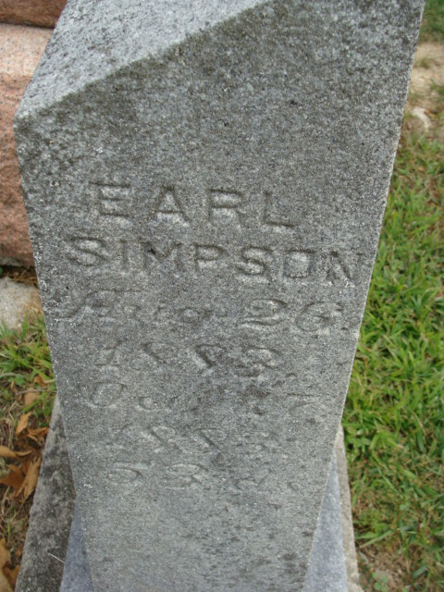
Photo by Alicia Kneuss

No further information found at this time

