Virgil Ray Simon
February 17, 1898 – February 8, 1904

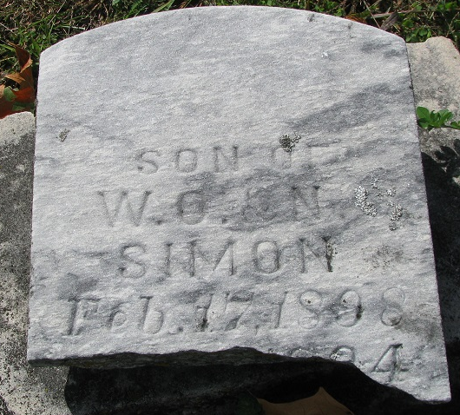
Photo by PLS

A SAD DEATH - Little Virgil Simons Dies of Fever
Was Visiting his Grandparents, and Was Ill but Thirty-four Hours

Virgil Simons, the six-year-old son of Mr. and Mrs. Simons of Oregon died yesterday evening at the home of his grandparents, John Drummond in this city, of scarlet fever. The death of this little boy is a very sad one owing to the facts and circumstances surrounding the case. Mrs. Simons and her son, Virgil, came here sometime during the holidays to visit her father who was, and is still, quite sick, and it was while here and upon this mission that the little one was stricken with that dread disease, scarlet fever. He was only sick thirty-four hours and his constitution was unable to bear up under this disease. Mrs. Simons, the mother, would desire very much to take her sons remains to Oregon, but the railroads refuse to haul the remains of a person who has died of a contagious disease.
The funeral will be held this afternoon sometime and will be a private affair and interment will be made in Maplewood Cemetery.
Mrs. Simons was formerly Miss Nettie Drummond and is well known here among the young people.

Decatur Daily Democrat; Adams County, Indiana
Tuesday, February 9, 1904

**
Indiana, U.S., Death Certificates, 1899-2017
Name Virgil Ray Simon
Gender Male
Race White
Marital Status Single
Age 5
Birth Date 17 Feb 1898
Birth Place Huntertown, Indiana
Death Date 8 Feb 1904
Death Place Decatur, Adams, Indiana, USA
Death Registration Date 1904
Father W O Simon
Mother Nettie Drummond
Informant Nellie Simon; Salem, Oregon
Burial February 9, 1904; Maplewood Cemetery

