Teddy W. Simon
June 21, 1934 – August 3, 2002

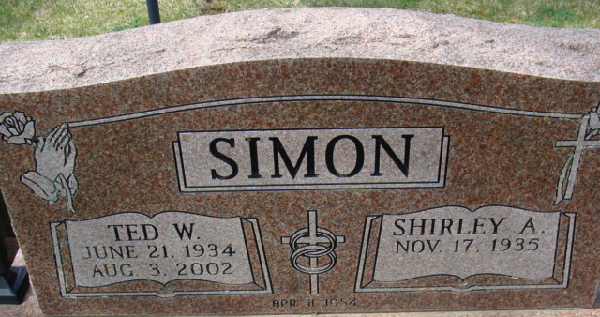
Photo by Alicia Kneuss

Teddy W Simon
in the Indiana, U.S., Death Certificates, 1899-2017
Name Teddy W Simon
Gender Male
Race White
Marital Status Married
Age 68
Birth Date 21 Jun 1934
Birth Place Indiana
Death Date 3 Aug 2002
Death Place Decatur, Adams, Indiana, USA
Death Registration Date 2002
Father Chester Simon
Mother E Lucile McMichael
Spouse Shirley A Leonard
Informant Shirley A. Simon; wife; Decatur, Indiana
Burial August 6, 2002; Decatur Cemetery; Decatur, Indiana

