Shirley Ann (Leonard) Simon
November 17, 1935 -

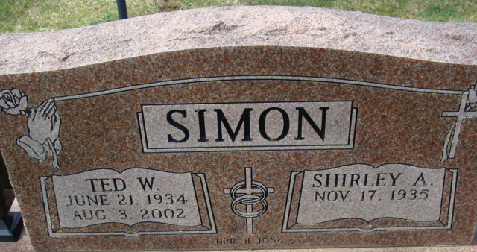
Photo by Alicia Kneuss

Shirley Ann Leonard
in the Indiana, U.S., Birth Certificates, 1907-1944
Name Shirley Ann Leonard
Gender Female
Birth Date 17 Nov 1935
Birth Place Portland, Jay, Indiana, USA
Father Ralph Edwin Leonard; age 22
Mother Lillian Pearl Thomas; age 16; 1st child
Certificate Number 45455
Roll number 40474_357212
Volume Range 88 - 92

**
Indiana, U.S., Marriage Certificates, 1960-2012
Name Shirley A Simon
[Shirley A Leonard]
Gender Female
Marriage Age 68
Birth Date abt 1936
Birth Place Indiana
Marriage Date 13 Aug 2004
Marriage Place Evansville, Vanderburgh, Indiana, USA
Marriage Registration Date 2004
Father Ralph Edwin Leonard
Mother L Pearl Leonard
Spouse James E Mosser
Notes 2 N
Reference Number 1 Bx1451
Reference Number 2 Tr8651
Certificate Number 031860
Volume Number 61-64

