Emery Blain Simmons
July 7, 1891 – January 24, 1953

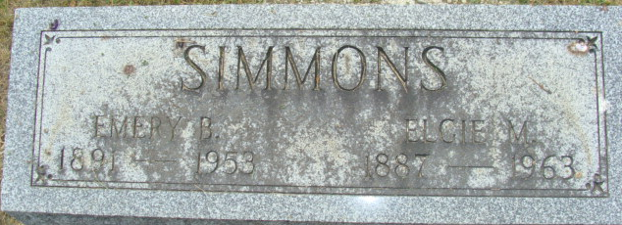
Photo by Alicia Kneuss

Emery B Simmons
in the U.S., Social Security Applications and Claims Index, 1936-2007
Name Emery B Simmons [Emery Blaine Simmons]
Birth Date 7 Jul 1891
Birth Place Noble County, Indiana
Death Date 24 Jan 1953
Claim Date 13 Mar 1953
SSN xxx
Notes 10 Mar 1953: Name listed as EMERY B SIMMONS
**
Indiana, U.S., Marriages, 1810-2001
Name Emery Blain Simmons
Gender Male; Race White
Event Type Marriage Registration (Marriage)
Birth Place Tipton
Marriage Date 24 Mar 1917
Marriage Place Bluffton, Indiana, United States
Residence Place Tipton
Father Jesse Simmons; Mother Mary Conrad
Spouse Dorothy Irene Beason
Page 163
**
Indiana, U.S., Marriage Certificates, 1960-2012
Name Emery Simmons
Marriage Age 48
Birth Date 7 Jul 1891
Marriage Date 12 Aug 1939
Marriage Place Grant, Indiana, USA
Father Jesse G. Simmons; Mother Mary Conrad
Spouse Elgie May Bohnke
Certifier Mildred L. White
Officiator Myrtle M Evans

