Elgie May (Croy) Simmons
August 13, 1887 – October 20, 1963

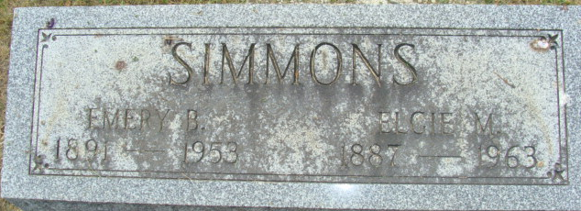
Photo by Alicia Kneuss

Mrs. Elgie Simmons Dies Early Sunday

Mrs. Elgie May Simmons, 76, of Decatur route 3, a resident of this area most of her life, died at 2 o’clock Sunday morning at the Wells County Hospital at Bluffton, where she had been a patient one week.
She was born in Blackford County Aug. 13, 1887, a daughter of Columbus and Nancy Crite-Croy. Her husband, Emery Simmons, preceded her in death. Mrs. Summons attended the Church of the Nazarene.
Surviving are three daughters, Mrs. Marie DeLong of Decatur, Mrs. Bessie Ladig of New Haven and Mrs. Audrey Spencer of Leesburg; two sons, William and Raymond Huston, both of Decatur, and 10 grandchildren.
Funeral services will be conducted at 2 p.m. Tuesday at the Gillig & Doan Funeral Home, with the Rev. W. R. Watson officiating. Burial will be in the Decatur Cemetery. Friends may call at the funeral home until time the services.

Berne Library Heritage Room, Adams County, Indiana
Adams County Obits 1962-1964
Handwritten date: Monday, October 4, 1963 (sic)

**
Indiana, U.S., Death Certificates, 1899-2017
Name Elgia May Simmons [Elgia May Croy]
Gender Female; Race White
Marital Status Widowed
Age 76
Birth Date 13 Aug 1887
Birth Place Indiana
Death Date 20 Oct 1963
Death Place Bluffton, Wells, Indiana, USA
Father Columbus Croy
Mother Nanny Crite
Informant Mrs. Marie DeLong; daughter; Decatur, Indiana
Burial October 22, 1963; Decatur Cemetery; Decatur, Indiana

