Ralph E. Simerman
March 6, 1910 – October 17, 2003

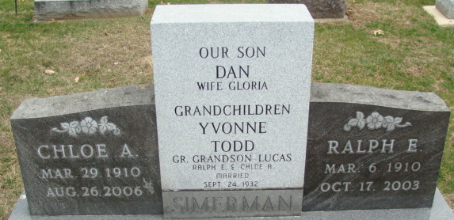
Photo by Alicia Kneuss

Ralph E. Simerman, 93
A native of Wells County, Ralph E. Simerman, 93, of Decatur, died Friday, Oct. 17 at 9:17 p.m. at the Adams County Memorial Hospital in Decatur. Born in Wells County on March 6, 1910 to Burr I. and Dollie Snyder Simerman, he married Chloe A. Dull on Sept. 24, 1932; she survives.
He was the retired owner of Simerman RV Sales in Decatur and was a member of the Decatur Masonic Lodge and St. Mark’s United Methodist Church.
Other survivors include a sister, Elizabeth Dull of Fort Wayne; two grandchildren; and one great-grandchild. He was preceded in death by a son, Dannie A. Simerman; two brothers, John and Roger Simerman; and a sister, Irene Slater.
Visitation will be today from 4 to 8 p.m. at Haggard & Sefton Funeral Home in Decatur, and for one hour prior to the service on Tuesday. There will be a Masonic Service at 8 p.m. this evening. Services will be held Tuesday at 11 a.m. at the funeral home. Burial in the Decatur Cemetery.
Preferred memorials to the church.
Bluffton News Banner, Wells County, Indiana
October 20, 2003

