Dannie A. Simerman
February 10, 1938 – March 4, 1995

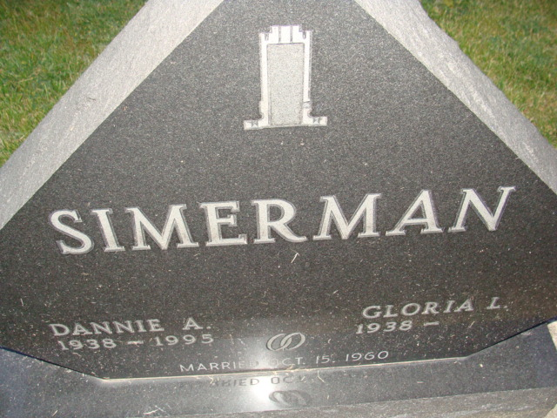
Photo by Alicia Kneuss

Dannie A Simerman
in the Indiana, U.S., Death Certificates, 1899-2017
Name Dannie A Simerman
Gender Male
Race White
Marital Status Married
Age 57
Birth Date 10 Feb 1938
Birth Place Decatur, Indiana
Death Date 4 Mar 1995
Death Place Fort Wayne, Allen, Indiana, USA
Death Registration Date 1995
Father Ralph Simerman
Mother Chloe Dull
Spouse Gloria Fugate
Informant Gloria Simerman; wife; Decatur, Indiana
Burial March 8, 1995; Decatur Cemetery; Decatur, Indiana

