Chloe A. (Dull) Simerman
March 29, 1910 – August 26, 2006

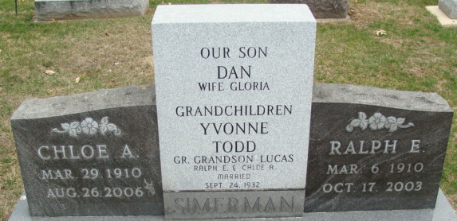
Photo by Alicia Kneuss

Chloe A. Simerman, 96 of Decatur passed away Saturday August 26th at Evergreen Assisted Living in Decatur, IN. She was born on March 29, 1910 in Wren, OH to Charles C. Dull and Bessie E. (Bell). Chloe married Ralph E. Simerman on September 24, 1932.
She is survived by one grandson Todd A. Simerman of Indianapolis, IN; one granddaughter Yvonne S. Simerman of Nashville, TN; one daughter-in-law Gloria Simerman of Decatur, IN; one great grandson and one niece. She was preceded in death by her husband Ralph E. Simerman, her son Dannie A. Simmmerman, two sisters and one brother.
She worked as homemaker and was a member of St. Mark's United Methodist Church.
Visitation will be from 10:00 am - Noon on Tuesday, August 29, 2006 at Haggard & Sefton Funeral Home. Funeral Service will be held at Noon on Tuesday at the funeral home. Officiating will be Rev. Jeff Taylor & Rev. Fuhrman Miller. Burial will be in the Decatur Cemetery.
Memorials may be made to St. Mark's United Methodist Church.

Haggard & Sefton Funeral Home, Adams County, Indiana
August 27, 2006

