Letitia Jane (Roberts) Long-Simcoke
February 9, 1825 – November 29, 1887

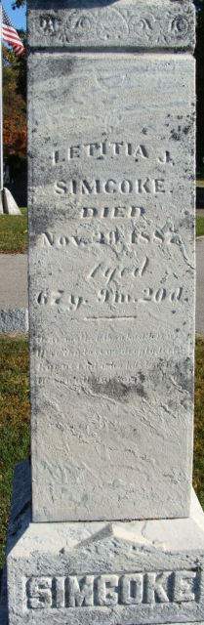
Photo by Deb Curry

Letitia Jane Roberts from tree Family tree's from Ohio and Indiana
Birth 9 Feb 1825 Franklin, Richland, Ohio, USA
Marriage 30 Oct 1853 Adams, Champaign, Ohio, USA
Residence 1880 Adams, Indiana, USA
Death 29 Nov 1887 Decatur, Adams, Indiana, USA
Father Owen Roberts (1782-1856)
Mother Letticia Williams (1785-1865)
Spouse Jeremiah Long (1810-1850
Spouse James Bryant Simcoke (1810-1888)

