Joseph B. Simcoke
February 27, 1860 – March 13, 1929

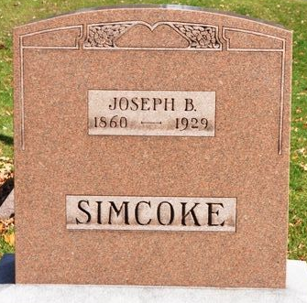
Photo by Deb Curry

Joseph B Simeoke
in the Indiana, U.S., Death Certificates, 1899-2017
Name Joseph B Simcoke
Gender Male
Race White
Marital Status Single
Age 69
Birth Date 27 Feb 1860
Birth Place Adams County, Indiana
Death Date 13 Mar 1929
Death Place Washington, Adams, Indiana, USA
Death Registration Date 1929
Father James Simcoke
Mother Letetia Roberts
Informant Mrs. R. D. Myers; Decatur, Indiana
Burial March 15, 1929; Decatur Cemetery

