Elizabeth (Brown) Simcoke
March 23, 1816 – May 15, 1853

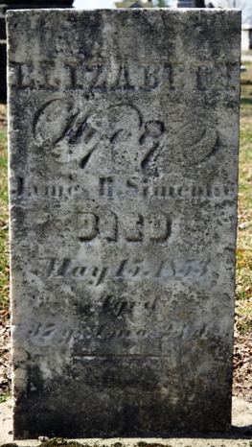
Photo by Deb Curry

Elizabeth Brown from tree Heineman Family Tree
Birth 23 Mar 1816 Livingston, Overton, Tennessee, USA
Marriage 17 Mar 1835 Overton, Tennessee, USA
Residence 1850 Decatur, Adams, Indiana, USA
Death 15 May 1853 Decatur, Adams, Indiana, USA
Mother Mary Brady Brown
Spouse James Bryant Simcoke (1810-1888)

