Ralph D. Sills
July 17, 1929 – June 6, 1998

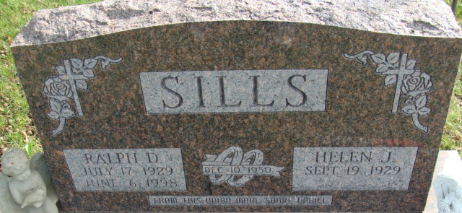
Photo by Alicia Kneuss

Ralph D. Sills, 68, died Saturday at home. He retired from Hoosier Wire Die and from Richards Restaurant. He was a Korean War Army veteran.
Surviving are his wife, Helen J.; a son, Daniel J. of Guyton, Ga.; two daughters, Mari Hart of Decatur and Shari Simpkins of New Haven; five brothers, Isaac of Huntington, Paul of Fort Wayne, David and Walter, both of Bluffton, and Charles of Poneto; three sisters, Ruth Sprow and Clara Bayes, both of Fort Wayne, and Rose Mattes of New Haven; three grandchildren; and two great-grandchildren.
Private graveside services at Decatur Cemetery, with military graveside rites by American Legion Post No. 43. Calling from 2 to 8 p.m. Tuesday at Haggard & Sefton Funeral Home, Decatur, with Masonic services at 8:45 p.m.
Memorials to donor's choice.

Journal Gazette, Allen County, Indiana
Monday, June 8, 1998

**
Indiana, U.S., Death Certificates, 1899-2017
Name Ralph D. Sills
Gender Male; Race White
Marital Status Married
Age 68
Birth Date 17 Jul 1929
Birth Place Adams County
Death Date 6 Jun 1998
Death Place Fort Wayne, Allen, Indiana, USA
Death Registration Date 1998
Father Walter Sills
Mother Mildred Miller
Spouse Helen J. Railing
Informant Helen J. Sills; wife; Fort Wayne, Indiana
Burial June 10, 1998; Decatur Cemetery; Decatur, Indiana

