Helen Jane (Railing) Sills
September 19, 1929 -

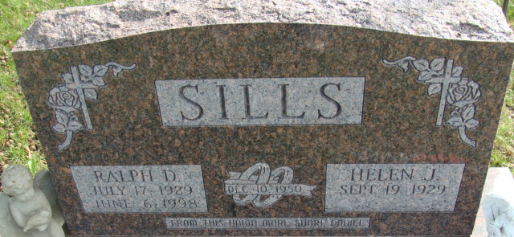
Photo by Alicia Kneuss

Helen Jane Railing
in the Indiana, U.S., Birth Certificates, 1907-1944
Name Helen Jane Railing
Gender Female
Birth Date 19 Sep 1929
Birth Place Penn, Jay, Indiana, USA
Father Forrest Jacob Railing; age 32
Mother Mary Alice Garner; age 34; 6th child, all living
Certificate Number 41200
Roll number 40474_356496
Volume Range 81 - 85

