Wendall John Siela
June 13, 1921 – June 22, 1930

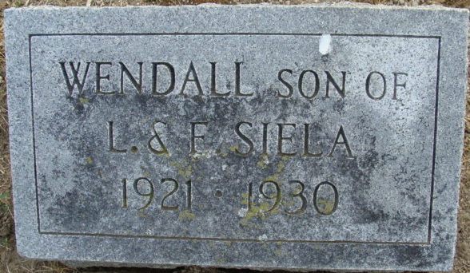
Photo by Alicia Kneuss

Nendall John Siela
in the Indiana, U.S., Death Certificates, 1899-2017
Name Wendall John Siela
Gender Male
Race White
Marital Status White
Age 9
Birth Date 13 Jun 1921
Birth Place Rantoul, Illinois
Death Date 22 Jun 1930
Death Place Union, Adams, Indiana, USA
Death Registration Date 1930
Father Leo Siela
Mother Emma J Nelson
Informant Leo Siela; Decatur, Indiana
Burial June 24, 1930; Decatur Cemetery

