Audrey Louise Siela
January 21, 1923 – April 22, 1930

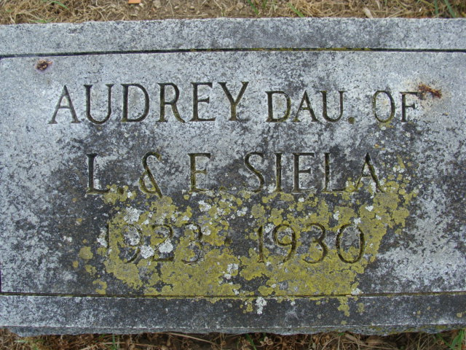
Photo by Alicia Kneuss

Andrey Louise Siela
in the Indiana, U.S., Death Certificates, 1899-2017
Name Andrey Louise Siela
Gender Female
Race White
Marital Status Single
Age 7
Birth Date 21 Jan 1923
Birth Place Rantoul, Illinois
Death Date 22 Apr 1930
Death Place Union, Adams, Indiana, USA
Death Registration Date 1930
Father Leo Siela
Mother Emma S Nelson
Informant Leo Siela; Decatur, Indiana
Burial April 24, 1930; Decatur Cemetery

