Patricia Lou (Gaffer) Sieger
June 3, 1928 – February 20, 1977

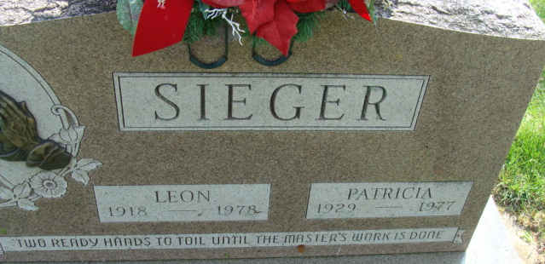
Photo by Alicia Kneuss

Patricia Lou Sieger
in the Indiana, U.S., Death Certificates, 1899-2017
Name Patricia Lou Sieger
[Patricia Lou Gaffer]
Gender Female
Race Caucasian (White)
Age 48
Marital Status Married
Birth Date 3 Jun 1928
Birth Place Indiana
Death Date 20 Feb 1977
Death Place Decatur, Adams, Indiana, USA
Death Registration Date 1977
Father John E. Gaffer
Mother Ethel Leist
Spouse Leon Sieger
Informant Leon Sieger; husband; Decatur, Indiana
Burial February 23, 1977; Decatur Cemetery; Decatur, Indiana

