Leon A. Sieger
January 10, 1918 – September 24, 1978

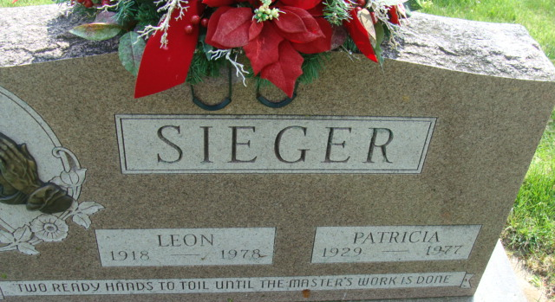
Photo by Alicia Kneuss

Leon A Sieger
in the Indiana, U.S., Death Certificates, 1899-2017
Name Leon A Sieger
Gender Male
Race White
Age 60
Marital Status Widowed
Birth Date 10 Jan 1918
Birth Place Ohio
Death Date 24 Sep 1978
Death Place Fort Wayne, Allen, Indiana, USA
Death Registration Date 1978
Father Fred Sieger
Mother Anna Grubb
Informant Terry Sieger; Woodburn, Indiana
Burial September 27, 1978; Decatur Cemetery; Decatur, Indiana

