Evelyn Elizabeth (Shilling) Siders-Clark
March 14, 1909 – February 8, 1996

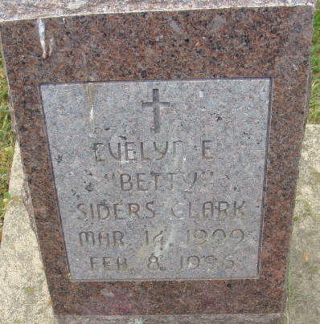
Photo by Alicia Kneuss

Evelyn Elizabeth Siders-Clark, 86, died Thursday at Woodcrest Nursing Center, Decatur. Born in Anderson, she was a homemaker. Her husband, William H., died in 1966.
Surviving are four daughters, Shirley Clark, Alta M. Thatcher, Shelby J. Hirshey and Mary Siders, all of Decatur; 13 grandchildren; 28 great-grandchildren; a great-great-grandchild; three stepchildren; and six step grandchildren.
Services at 11 a.m. Saturday at Zwick-Sefton & Jahn Funeral Home, Decatur. Calling beginning at 9 a.m. Saturday. Burial in Beery Cemetery, Decatur (sic).
Memorials to donor's choice.

Journal Gazette, Allen County, Indiana
Friday, February 9, 1996

**
Indiana, U.S., Death Certificates, 1899-2017
Name Evelyn E Clark
[Evelyn E Shillig]
Gender Female
Race White
Marital Status Widowed
Age 86
Birth Date 14 Mar 1909
Birth Place Anderson, Indiana
Death Date 8 Feb 1996
Death Place Decatur, Adams, Indiana, USA
Death Registration Date 1996
Father John White Shillig
Mother Mary Elizabeth Laurence
Informant Shirley Clark; daughter; Decatur, Indiana
Burial February 10, 1996; Decatur Cemetery; Decatur, Indiana
**
Indiana, U.S., Marriages, 1810-2001
Name Evelyn Elizabeth Shilling
Gender Female
Race White
Age 17
Event Type Marriage Registration (Marriage)
Birth Date 14 Mar 1909
Birth Place Anderson, Indiana
Marriage Date 25 May 1926
Marriage Place Indiana, United States
Father Charles Shilling
Mother Mary Lawrence
Spouse William H Blue
Page 9

