Blanch M. Shullaw
May 5, 1901 – April 17, 1997

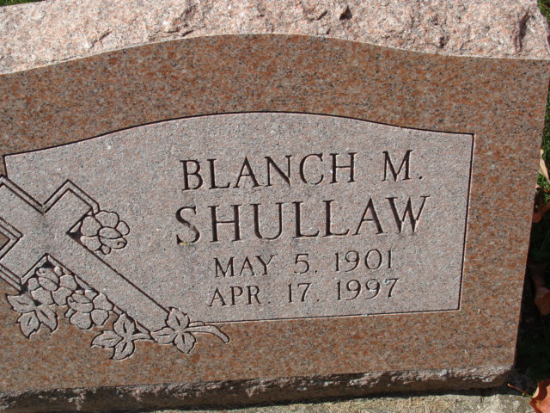
Photo by Alicia Kneuss
Blanch M. Shullaw, 95, of Decatur died Thursday at her home. The Wyoming, Ill., native retired from People's Gas Light & Coke Company in Chicago after 44 years.
Surviving is a nephew, J. Harold of London; a great-nephew, Richard of Washington, D.C.; great-nieces, Mari of London, England, and Dianne Shullaw O'Connell of Anchorage, Ala.
Services are at 1 p.m. Tuesday at Zwick-Sefton & Jahn Funeral Home, Decatur, with burial in Decatur Cemetery. Calling is 2 to 4 p.m. and 7 to 9 p.m. Monday at the funeral home.
Memorials are to Moody Bible Institute or Adams County Home Health.

News-Sentinel, Allen County, Indiana
Saturday, April 19, 1997

**
Indiana, U.S., Death Certificates, 1899-2017
Name Blanch M. Shullaw
Gender Female
Race White
Marital Status Never
Age 95
Birth Date 5 May 1901
Birth Place Wyoming Illinois
Death Date 17 Apr 1997
Death Place Decatur, Adams, Indiana, USA
Death Registration Date 1997
Father Benjamin Shullaw
Mother Sarah Belle Jackson
Informant Mrs. Dolores Carpenter; friend; Decatur, Indiana
Burial April 22, 1997; Decatur Cemetery; Decatur, Indiana

