Patricia (Connor) Shroyer
March 5, 1922 – March 4, 2010

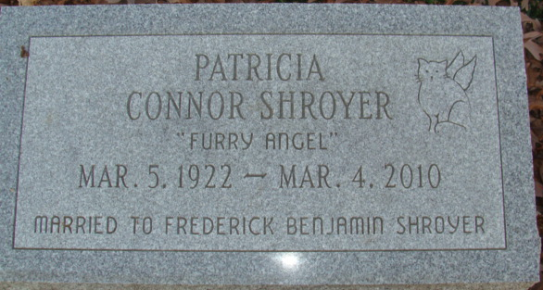
Photo by Alicia Kneuss
Patricia Shoyer. The vote is in. The World's Best Mother, Patricia Shoyer, will be missed by her family and friends. She returned to her Heavenly Father on March 4, 2010 one day before her 88th birthday. Patricia was born on March 5, 1922, in Denver, Colorado, to Patrick and Grace Connor. From the time she was seven years old, she lived in California.
She graduated from the University of Southern California with a bachelor's degree in sociology in 1944. She was awarded a full ride scholarship and was awarded membership to Phi Beta Kappa in her junior year.
She survived her three husbands: Dr. Frederick Shroyer, Dr. Henry Van Slooten, and Dr. Daniel Amneus. She was a talented writer and had a great sense of humor.
She loved her family deeply. She is survived by her only child, Madeline (Shroyer) Christophiades; son-in-law George Christophiades; and grandchildren Frederick Wells Christophiades, Patricia Julia Christophiades, Daniel Conner Christophiades. We were also thankful she was our Mother and grandmother. One of her greatest legacies to her daughter was instilling the belief that she could do anything her father, Dr. Frederick Shroyer, could do. Millions of thanks to Mountain Ridge Assisted Living in South Ogden, Utah, and Hospice of Utah for their wonderful and kind care of Patricia.
Patricia first husband, Dr. Frederick Shroyer, used to say, "Death is a long sleep from which you awaken whenever someone thinks of you." If this is true, Mom, don't expect much rest in the decades to come! Safe journey, Mom! Private graveside services were held on Wednesday, March 17, 2010, in Decatur Cemetery.
Decatur Daily Democrat, Adams County, Indiana
Thursday, March 18, 2010
**
California, U.S., Marriage Index, 1949-1959
Name Patricia Connor
Gender Female
Estimated Birth Year abt 1925
Age 24
Marriage Date 13 Jan 1949
Marriage Place Los Angeles, California, USA
Spouse Frederck B Shroyer
Spouse Age 32
**

U.S., Social Security Death Index, 1935-2014
Name Patricia Connor Shroyer Amneus
Social Security Number xxx
Birth Date 5 Mar 1922
Issue year Before 1951
Issue State California
Last Residence Utah
Death Date 4 Mar 2010

