Frederick Benjamine Shroyer
October 28, 1916 – August 24, 1916

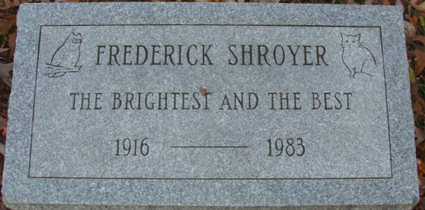
Photo by Alicia Kneuss
Frederick Benjamine Schroyer
in the Indiana, U.S., Birth Certificates, 1907-1944
Name Frederick Benjamine Schroyer
Gender Male
Birth Date 28 Oct 1916
Birth Place Decatur, Adams, Indiana, USA
Father Benj F. Schroyer; age 28
Mother Hulda S. Mutchler; age 23; 1st child
Certificate Number 473
Roll number 40474_357868
Volume Range 1 - 2000
**
California, U.S., Death Index, 1940-1997
Name Frederick B Shroyer
Social Security # xxx
Gender Male
Birth Date 28 Oct 1916
Birth Place Indiana
Death Date 24 Aug 1983
Death Place Los Angeles
Mother's Maiden Name Mutschler

