Lawrence M. Shroll
1902 - 1902

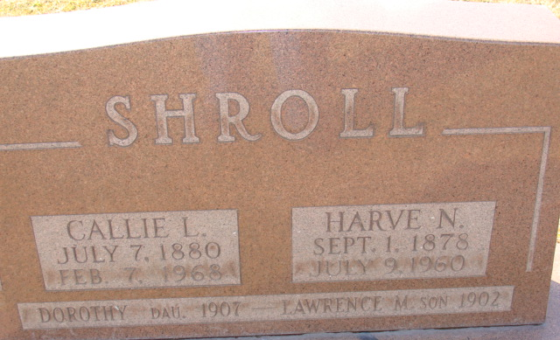
Photo by Alicia Kneuss

Lawrence M Shroll from tree Oliver/Smitley Family Tree
Birth 1902 Decatur, Adams, Indiana, USA
Death 1902 Decatur, Adams, Indiana, USA
Father Harve Newton Shroll (1878-1960)
Mother Callie Luella Tester (1880-1968)
1955 People 1 Record 3 Sources

