Harve N. Shroll
September 1, 1878 – July 9, 1960

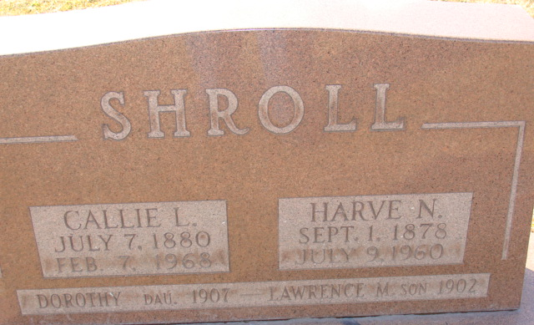
Photo by Alicia Kneuss

Harve Shroll Dies Early This Morning

Harve N. Shroll, 81, well known Decatur man, died suddenly at 2:30 o'clock this morning at Lake James, where he and his wife had gone for a vacation trip Friday morning. Mr. Shroll became ill shortly after noon Friday. Death was believed caused by a heart attack.
Mr. Shroll, who had been associated with the Schafer Store here for 48 years before his retirement in 1948, and his wife had been making their home in Bradenton, Fla., for the past five years, but have spent much of the summer months in Decatur and Lake James.
He was born in Monroe Sept. 1, 1878, a son of George and Amanda Oliver-Shroll, and was married to Callie Tester Aug. 1, 1900.
Mr. Shroll was a member of the First Baptist Church and the Masonic Lodge and was a 32nd degree Mason.
Surviving in addition to his wife are three daughters, Mrs. O.D. (Grace) Thundere of Fort Wayne, Mrs. Helen Zwick, wife of Dr. Harold F. Zwick of Decatur, and Mrs. Joseph (Edwina) Wolfrey of Eaton, O.; one brother, one sister, seven grandchildren and two great-grandchildren. One son and one daughter preceded him in death.
Funeral services will be conducted at 10:30 a.m. Monday at the Zwick Funeral Home, the Rev. Stuart Brightwell officiating. Burial will be in the Decatur Cemetery. Friends may call at the funeral home after 10 a.m. Sunday until time of the services.

Adams County Historical Museum, Adams County, Indiana
January 1958 – December 1960 Scrapbook, image 58-60
Handwritten date: Saturday, July 9, 1960

