Callie L. (Tester) Shroll
July 7, 1880 – February 7, 1968

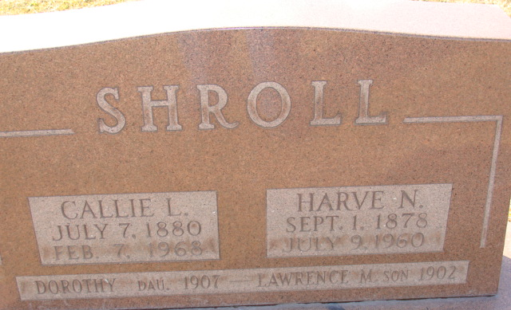
Photo by Alicia Kneuss

Callie L Shroll
in the Ohio, U.S., Death Records, 1908-1932, 1938-2022
Name Callie L Shroll
Gender Female
Race White
Marital Status Widowed
Death Age 87
Birth Date Abt 1881
Death Date 7 Feb 1968
Death Place Van Wert, Van Wert, Ohio, USA
Certificate Number 017454
Inquest Hospital Long-Term Care Facilities
Inquest Questions Certifier: Physician; Autopsy Performed?: Unknown;
**
Indiana, U.S., Marriages, 1810-2001
Name Celia [sic] L Tester
Gender Female
Race White
Event Type Marriage Registration (Marriage)
Birth Place Ohio
Marriage Date 1 Aug 1900
Marriage Place Decatur, Indiana, United States
Residence Place Decatur, Indiana
Father Jacob Tester
Mother Mary Miller
Spouse Harvey N Schroll
Page 95
FHL Film Number 002321357
**
Callie Luella Tester from Oliver/Smitley Family Tree
Spouse Harve Newton Shroll
Father Jacob A Tester
Mother Mary Ann Miller
Children Helen Nona
Birth 7 Jul 1880 Mercer, Ohio, USA
Death 7 Feb 1968 Convoy, Van Wert, Ohio, USA
Residence 1900 Adams, Indiana, USA

