Robert William Shraluka
September 22, 1912 – December 3, 1962

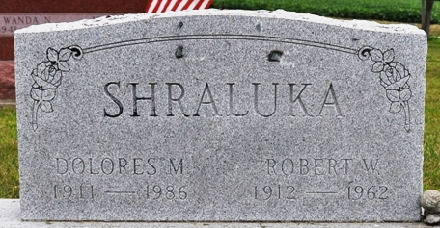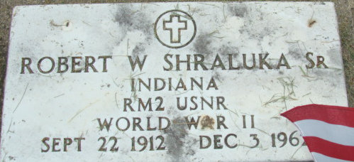
Photo by Deb Curry

Robert William Shralura
in the Indiana, U.S., Death Certificates, 1899-2017
Name Robert William Shraluka
Gender Male
Race White
Age 50
Marital Status Married
Birth Date 22 Sep 1912
Birth Place Indiana
Death Date 3 Dec 1962
Death Place Decatur, Adams, Indiana, USA
Death Registration Date 1962
Father Bart Shraluka
Mother Bertha Tricker
Informant Mrs. Robert W Shraluka; wife; Decatur, Indiana
Burial December 5, 1962; Decatur Cemetery; Decatur, Indiana

