Dolores M. (Elzey) Shraluka
June 28, 1911 – October 2, 1986

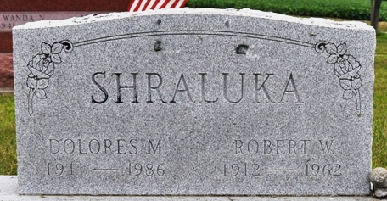
Photo by Deb Curry

Dolores M Shraluka
in the Indiana, U.S., Death Certificates, 1899-2017
Name Dolores M Shraluka
[Dolores M Elzey]
Gender Female
Race White
Age 75
Marital Status Widowed
Birth Date 28 Jun 1911
Birth Place Indiana
Death Date 2 Oct 1986
Death Place Decatur, Adams, Indiana, USA
Death Registration Date 1986
Father Harvey Elzey
Mother Margaret Beam
Informant Robert Shraluka; son; Decatur, Indiana
Burial: October 4, 1986; Decatur Cemetery; Decatur, Indiana

