Michael L. Shrader
February 18, 1953 – January 20, 2016

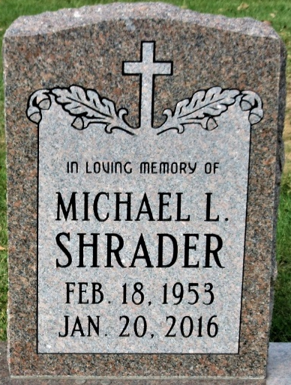
Photo by PLS

Michael L. Shrader, 62, of Decatur, IN, formerly of Tracy, CA, passed away at his residence on Wednesday, January 20, 2016. He was born on February 18, 1953 in Oakland, CA, the son of Robert L. and Paula A. (Gentling) Shrader.
He was a 1971 graduate of Marina High School and a former member of Hope Lutheran Church in Tracy, CA. He was currently employed by Bluffton Motor Works.
He is survived by a brother, Mark R. Shrader of Hayward, CA and a sister, Robin D. (Ron) Gonzales of Tracy, CA; close friends, Juanita Groce and Michael Rodriquez both of Decatur.
He was preceded in death by his mother, Paula A. Shrader; a brother, Stephen Paul Shrader; and his father, Eugene Lavenue.
A Funeral Service will be held at 11:00 a.m. on Thursday, January 28, 2016 at Haggard-Sefton & Hirschy Funeral Home, with visitation 2 hours prior to the service from 9:00 – 11:00 a.m. Burial will take place in the Decatur Cemetery.

Haggard & Sefton Funeral Home, Adams County, Indiana
January 21, 2016

