Charlene M. (Eyanson) Shoup
December 4, 1933 – October 3, 2014

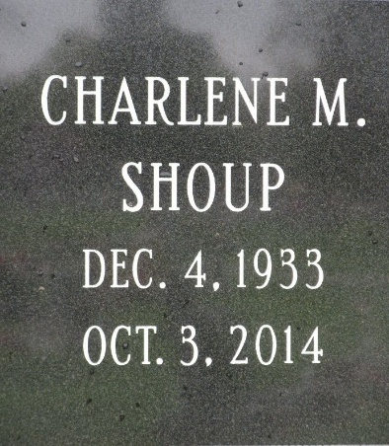
Photo by PLS

Charlene M. Shoup, 80 of Decatur, IN passed away Friday, October 3, 2014 at Lutheran Hospital. Charlene was born on December 4, 1933 in Decatur, IN to the late Charles D. and Mabel (Ladd) Eyanson. Charlene married Robert Shoup on October 31, 1953
Charlene was a member of St. Mark’s United Methodist Church. She was a member of the American Legion Auxiliary #43 and the Women of the Moose #1311. She was also involved in Operation Help in Adams County. She had retired as a Medical Secretary for Dr. H.S. Lee.
Survivors include her husband Robert Shoup of Decatur; sons Tom Shoup and Tim (Tammy) Shoup both of Decatur; daughters Jeanne (Cindy Lockhart) Shoup of Ft. Wayne, Janet (Dale) Werling of Decatur and Judi Woolfolk of Bumpass, VA; a brother Don Eyanson of Pensacola, FL; sisters Virginia Graft of Roanoke, IN and Naomi Boroff of El Paso, TX; 7 grandchildren, Jaime (Steve) Macklin, Lindsey Werling, Kristen Werling, Parker Woolfolk, Mamie Woolfolk, Stephanie Shoup and Spencer Shoup. She was preceded in death by a sister Agnes Miller.
Visitation will be 3:00-7:00 p.m. Tuesday, October 7, 2014 at Haggard-Sefton & Hirschy Funeral Home and 1 hour prior to services at the church. Funeral services will be at 10:00 a.m. Wednesday, October 8th at St. Mark’s United Methodist Church with Pastor Chris Gadlage officiating.
Memorials are to St. Mark’s UMC.

Haggard & Sefton Funeral Home, Adams County, Indiana
Saturday, October 3, 2014

